Julia Miele Rodas
with Mamadou Barry, Madeline Lewis, Eric Moore, Luis Moreau, and Julio Rodriguez
Radical Teacher: Anti-Oppressive Composition Pedagogies
21 October 2019

Radical Lessons in the Wake of Black Lives Matter
(master document for digital layout)
First things first: Everyone deserves access to important ideas and information. This is the primary reason behind presenting this essay in comic form as well as the primary motivation underlying the exercise this comic describes. Pictures and emphatic word-art help clarify complex concepts for many. Comics can provide a point of entry to discourse that might otherwise be marginally accessible; and using comics to teach and to learn disciplines readers and writers to pare away the nonessential and prioritize foundational content.
From the outset, though, it’s crucial to recognize that using visual tools and platforms to create widespread access often adds barriers for blind and visually impaired people whose participation in political and intellectual life is required as urgently as that of any others.
That’s why the following comic is augmented with plain text verbal description for every panel. This not only makes this graphic essay more accessible, it also foregrounds for all readers both a common problem of accessibility and one practical solution.
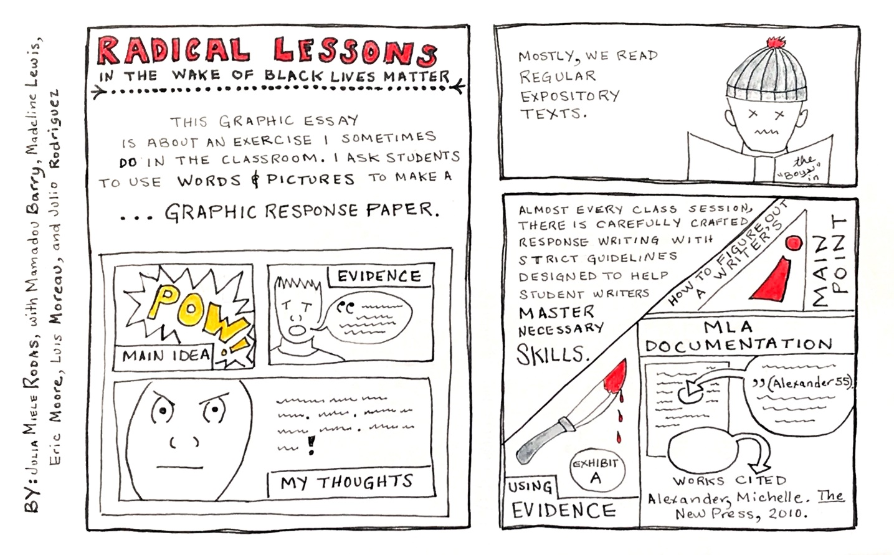
First page
(first of three frames): “Radical Lessons in the Wake of Black Lives Matter,” by Julia Miele Rodas, with Mamadou Barry, Madeline Lewis, Eric Moore, Luis Moreau, and Julio Rodriguez. This graphic essay is about an exercise I sometimes do in the classroom. I ask students to use words & pictures to make a … graphic response paper. Illustration: sample three frame comic, first frame has “pow!” in dramatic yellow letters with caption “main idea,” second frame shows cartoon head with speech bubble depicting generic text in quotation marks with caption “evidence,” third frame shows close up angry cartoon face with generic text at the side punctuated with exclamation point, captioned “my thoughts.”
(Second of three frames): Mostly, we read regular expository texts. Illustration: Bored cartoon face with knit cap and X-es for eyes reading a hardcover book with partial title, “The ‘Boys …”
(Third of three frames): Almost every class session, there is carefully crafted response writing with strict guidelines designed to help student writers master necessary skills. Illustration in three parts shows knife marked “exhibit A” dripping blood from the tip with caption “using evidence,” large exclamation point with caption “how to figure out a writer’s main point,” and magnified view of print page highlighting use of in-text citations and works cited entry with caption “MLA documentation.”
N.B. The entire comic written and drawn by hand in a naïve cartoon style, black ink with watercolor highlights and whimsical borders.
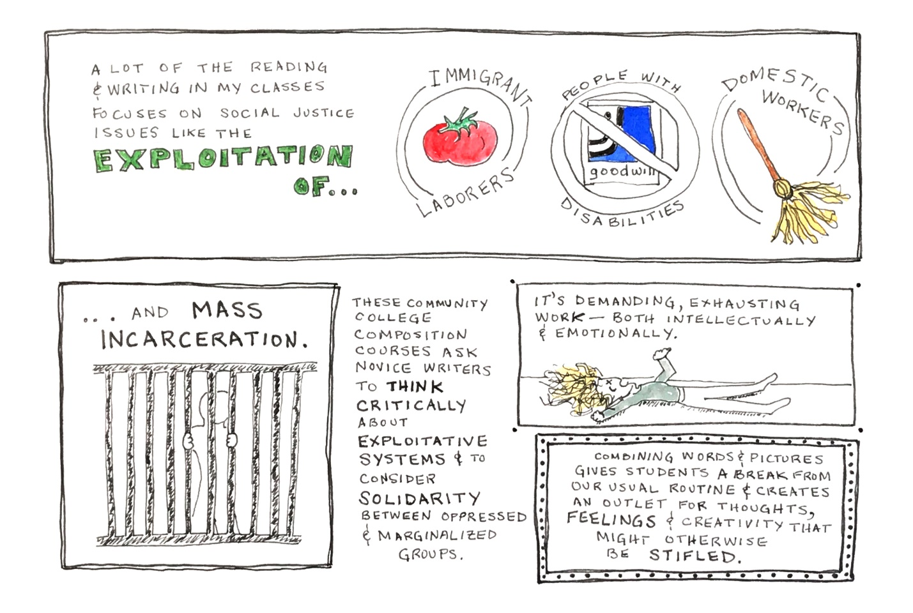
Second page
(first of five frames): A lot of the reading & writing in my classes focuses on social justice issues like the exploitation of … immigrant laborers, people with disabilities, domestic workers. Illustrations show a tomato associated with “immigrant laborers,” a crossed-out Goodwill logo for “people with disabilities,” and a mop for “domestic workers.”
(second of five frames): … and mass incarceration (with illustration of silhouetted figure behind bars).
(third of five frames): These community college composition courses ask novice writers to think critically about exploitative systems & to consider solidarity between oppressed & marginalized groups.
(fourth of five frames): It’s demanding, exhausting work—both intellectually & emotionally. Illustration: supine figure on the floor, arms and legs akimbo, with X-es for eyes, mouth gaping, and a mop of curly blond hair strewn out on the floor.
(fifth of five frames): Combining words & pictures gives students a break from our usual routine & creates an outlet for thoughts, feelings & creativity that might otherwise be stifled.

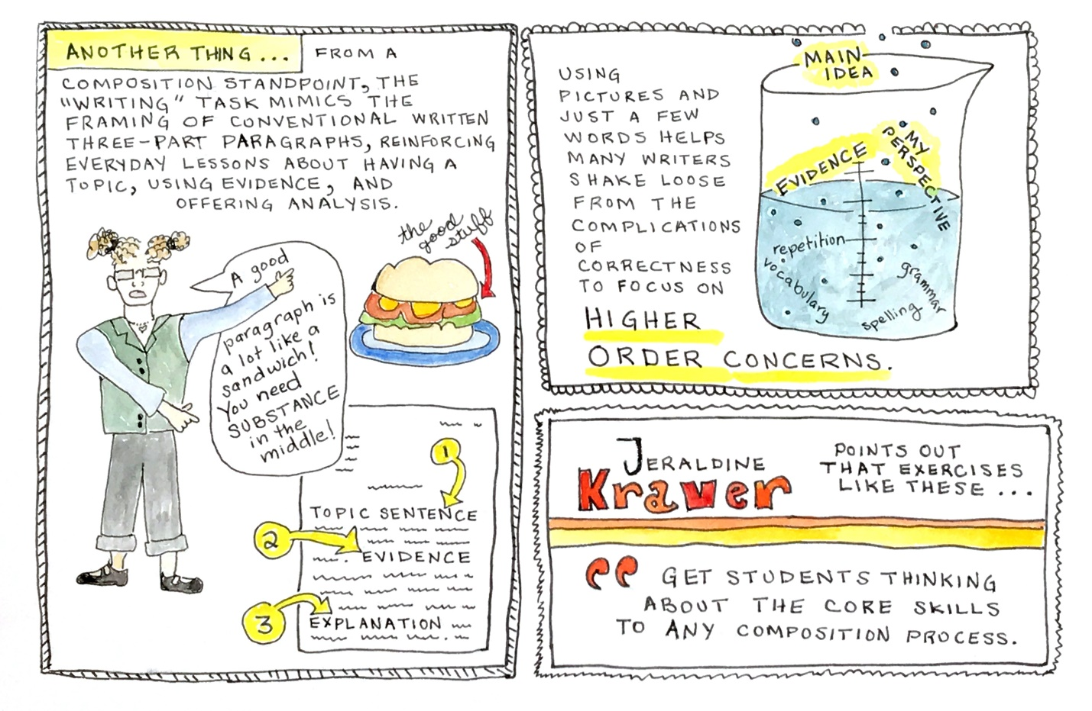
Third page
(first of three frames): Another thing … from a composition standpoint, the ‘writing’ task mimics the framing of conventional written three-part paragraphs, reinforcing everyday lessons about having a topic, using evidence, and offering analysis. Illustration depicts a curly-haired, glasses-wearing composition professor (the author) saying “A good paragraph is a lot like a sandwich! You need substance in the middle!” while pointing at a composition paper with numbered parts for “topic sentence,” “evidence,” and “explanation,” and a heavily loaded sandwich with an arrow pointing to the center and noting “the good stuff.”
(second of three frames): Using pictures and just a few words helps many writers shake loose from the complications of correctness to focus on higher order concerns. Illustration is a beaker half filled with fluid, words and bubbles percolating up from the bottom; from bottom to top, words are: “spelling,” “vocabulary,” “grammar,” “repetition,” with highlighted terms—“evidence,” “my perspective,” and “main point” floating to the surface and out of the top of the beaker.
(third of three frames): Jeraldine Kraver points out that exercises like these “get students thinking about the core skills to any composition process.” With bold orange and yellow stripes as flourish.

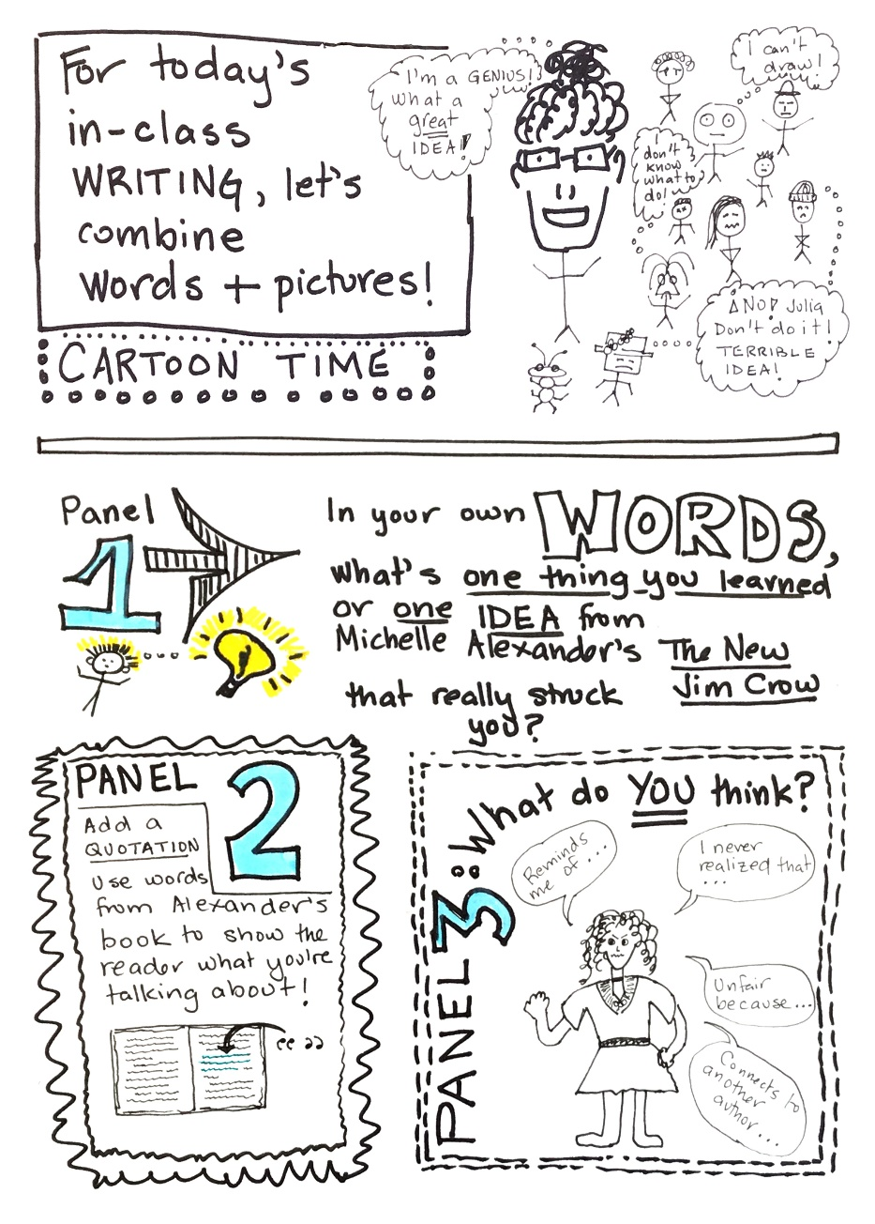
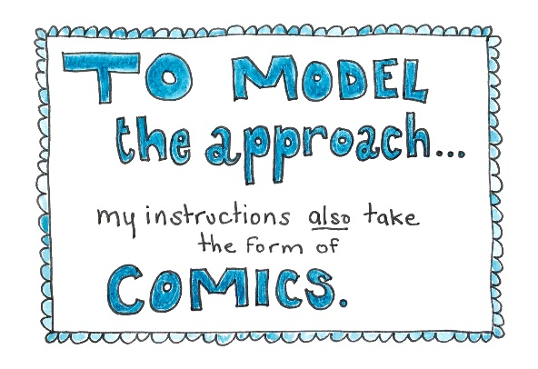

Fourth page
(first of five frames): To model the approach … my instructions also take the form of comics.
(second of five frames): For today’s in-class writing, let’s combine words + pictures! / Cartoon Time. Illustration shows stick-figure instructor, curly hair in a bun and wearing glasses, with an associated thought bubble, “I’m a genius! What a great idea!” surrounded by a diverse array of stick-figure students, not all of whom are human, with their own respective thought bubbles, including: “I can’t draw!” “I don’t know what to do!” and “¡No! Julia, don’t do it! Terrible idea!”
(third of five frames): Panel 1, In your own words, what’s one thing you learned or one idea from Michelle Alexander’s The New Jim Crow that really struck you? Illustration: Stick figure with thought represented by a giant glowing light bulb.
(fourth of five frames): Panel 2, Add a quotation. Use words from Alexander’s book to show the reader what you’re talking about! Illustration arrow pointing to a specific spot on the page of an open book with generic text.
(fifth of five frames): Panel 3, naïve cartoon figure, with curly hair, wearing dress surrounded by speech bubbles with the following prompts: “Reminds me of …,” “I never realized that …,” “Unfair because …,” and “Connects to another author …”

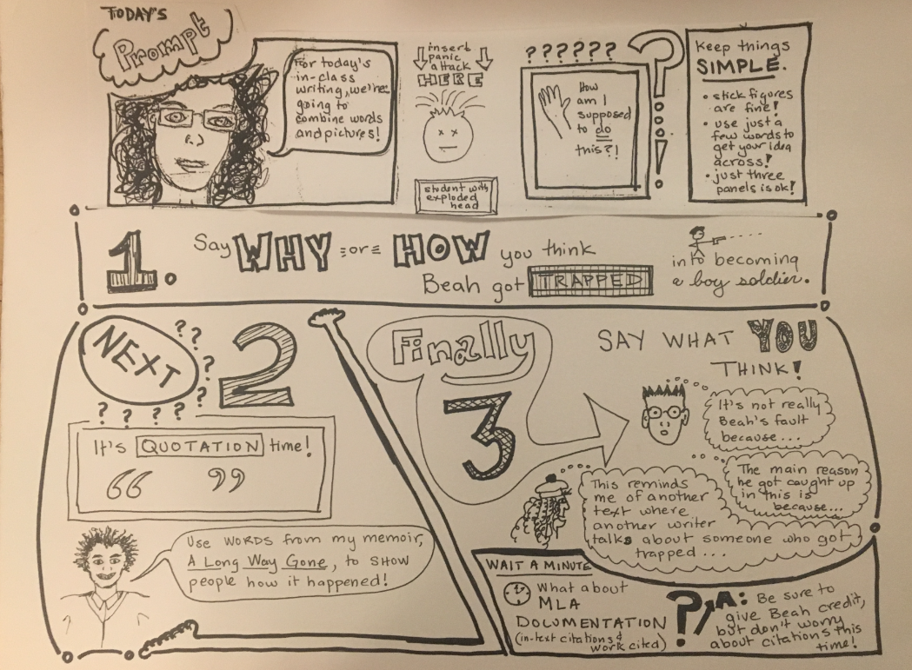
Fifth page
(first of eight frames): Today’s prompt. Illustration: Curly haired, glasses-wearing professor face with speech bubble saying, “For today’s in-class writing, we’re going to combine words and pictures!”
(second of eight frames): Illustration: arrows pointing to abstract face with X-es for eyes, noting “insert panic attack here” and captioned, “student with exploded head.”
(third of eight frames): How am I supposed to do this?! Illustration is raised hand.
(fourth of eight frames): Keep things simple. Stick figures are fine! Use just a few words to get your idea across! Just three panels is okay!
(fifth of eight frames): 1. Say why or how you think Beah got trapped into becoming a boy soldier. Illustration: stick figure shooting a handgun.
(sixth of eight frames): Next????? 2. It’s quotation time! Illustration: Curly-headed bust representing Ishmael Beah with speech bubble saying, “Use words from my memoir, A Long Way Gone, to show people how it happened!
(seventh of eight frames): Finally, 3, say what you think! Illustration: various student heads with the following thought bubbles, “It’s not really Beah’s fault because …,” “The main reason he got caught up in this is because …,” “This reminds me of another text where another writer talks about someone who got trapped …”
(eighth of eight frames): Wait a minute! What about MLA documentation (in-text citations & work cited)? A: Be sure to give Beah credit, but don’t worry about citations this time!

Sixth page
(first of four frames): What Purpose Does This Serve?
(second of four frames): For one … it’s a break from the grueling business-as-usual of the composition classroom.
(third of four frames): Abigail G. Scheg says: “By offering short creative writing assignments within the first-year composition class, we are giving our students a break from those traditional (and for many students, seemingly insurmountable) assignments to reaffirm their capabilities as unique individuals.” Illustration shows a standard-format composition page in portrait orientation with arrow pointing to second page in landscape format with tree, sun, stick figures and minimal text.
(fourth of four frames): It’s also a chance for less advanced readers to get a foothold in an assigned text, especially one that uses difficult language, or, that’s theoretically challenging. Illustration is a single bare foot.
[NOTE: I have discovered an error on this page; I will make the correction and send a corrected JPEG tomorrow! Correction has already been added to the description.]

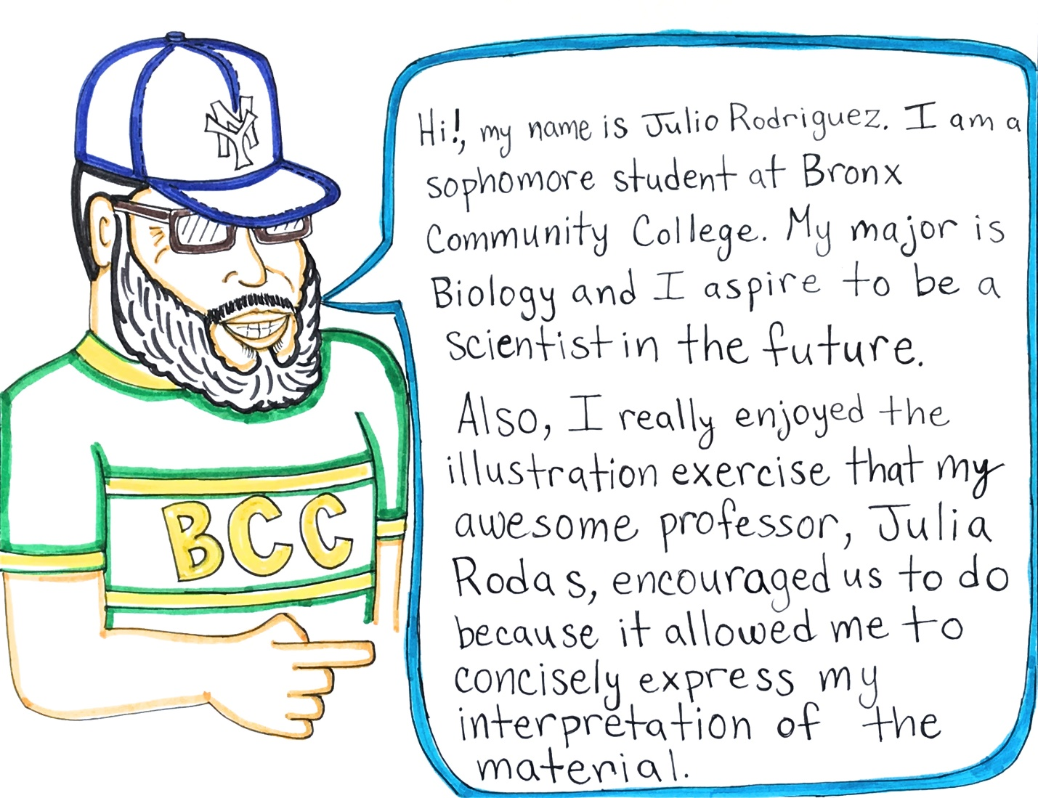

Seventh page
(one frame): Illustration is bearded figure with glasses and Yankees baseball cap wearing a BCC t-shirt, with speech bubble saying, “Hi! My name is Julio Rodriguez. I am a sophomore student at Bronx Community College. My major is Biology and I aspire to be a scientist in the future. Also, I really enjoyed the illustration exercise that my awesome professor, Julia Rodas, encouraged us to do because it allowed me to concisely express my interpretation of the material.”
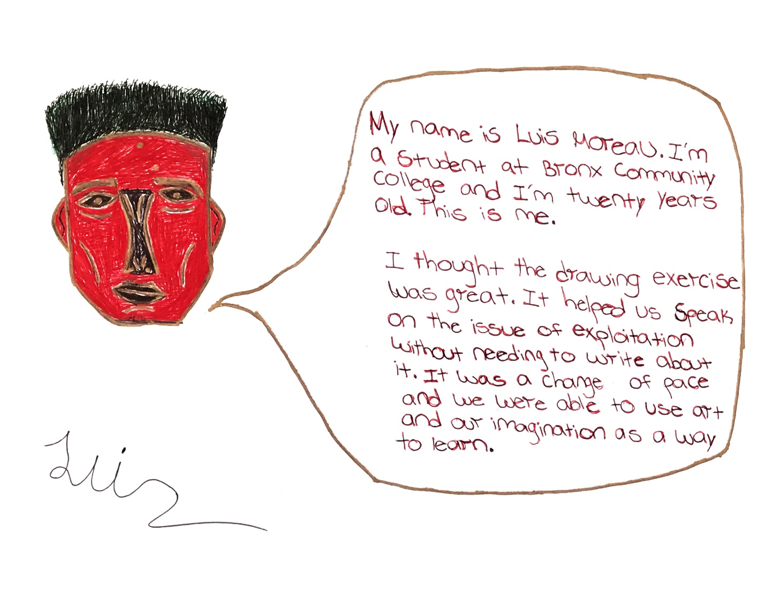

Eighth page
(one frame): Illustration is abstract/stylized red and black face, with speech bubble saying, “My name is Luis Moreau. I’m a student at Bronx Community College and I’m twenty years old. This is me. I thought the drawing exercise was great. It helped us speak on the issue of exploitation without needing to write about it. It was a change of pace and we were able to use art and our imagination as a way to learn.”

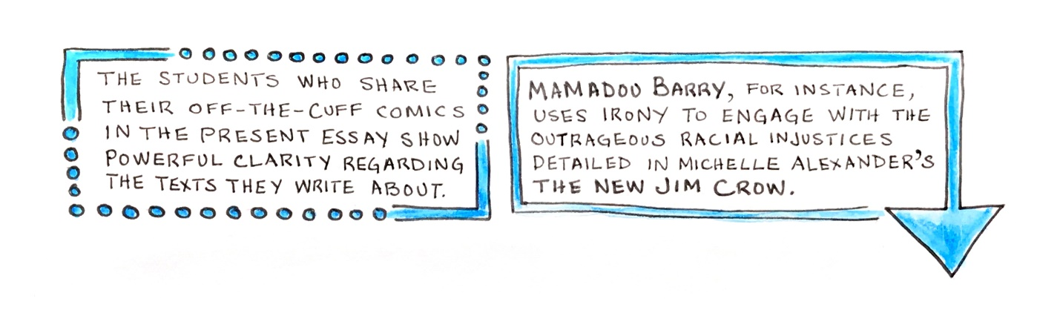
Ninth page
(one frame): The students who share their off-the-cuff comics in the present essay show powerful clarity regarding the texts they write about. Mamadou Barry, for instance, uses irony to engage with the outrageous racial injustices detailed in Michelle Alexander’s The New Jim Crow.

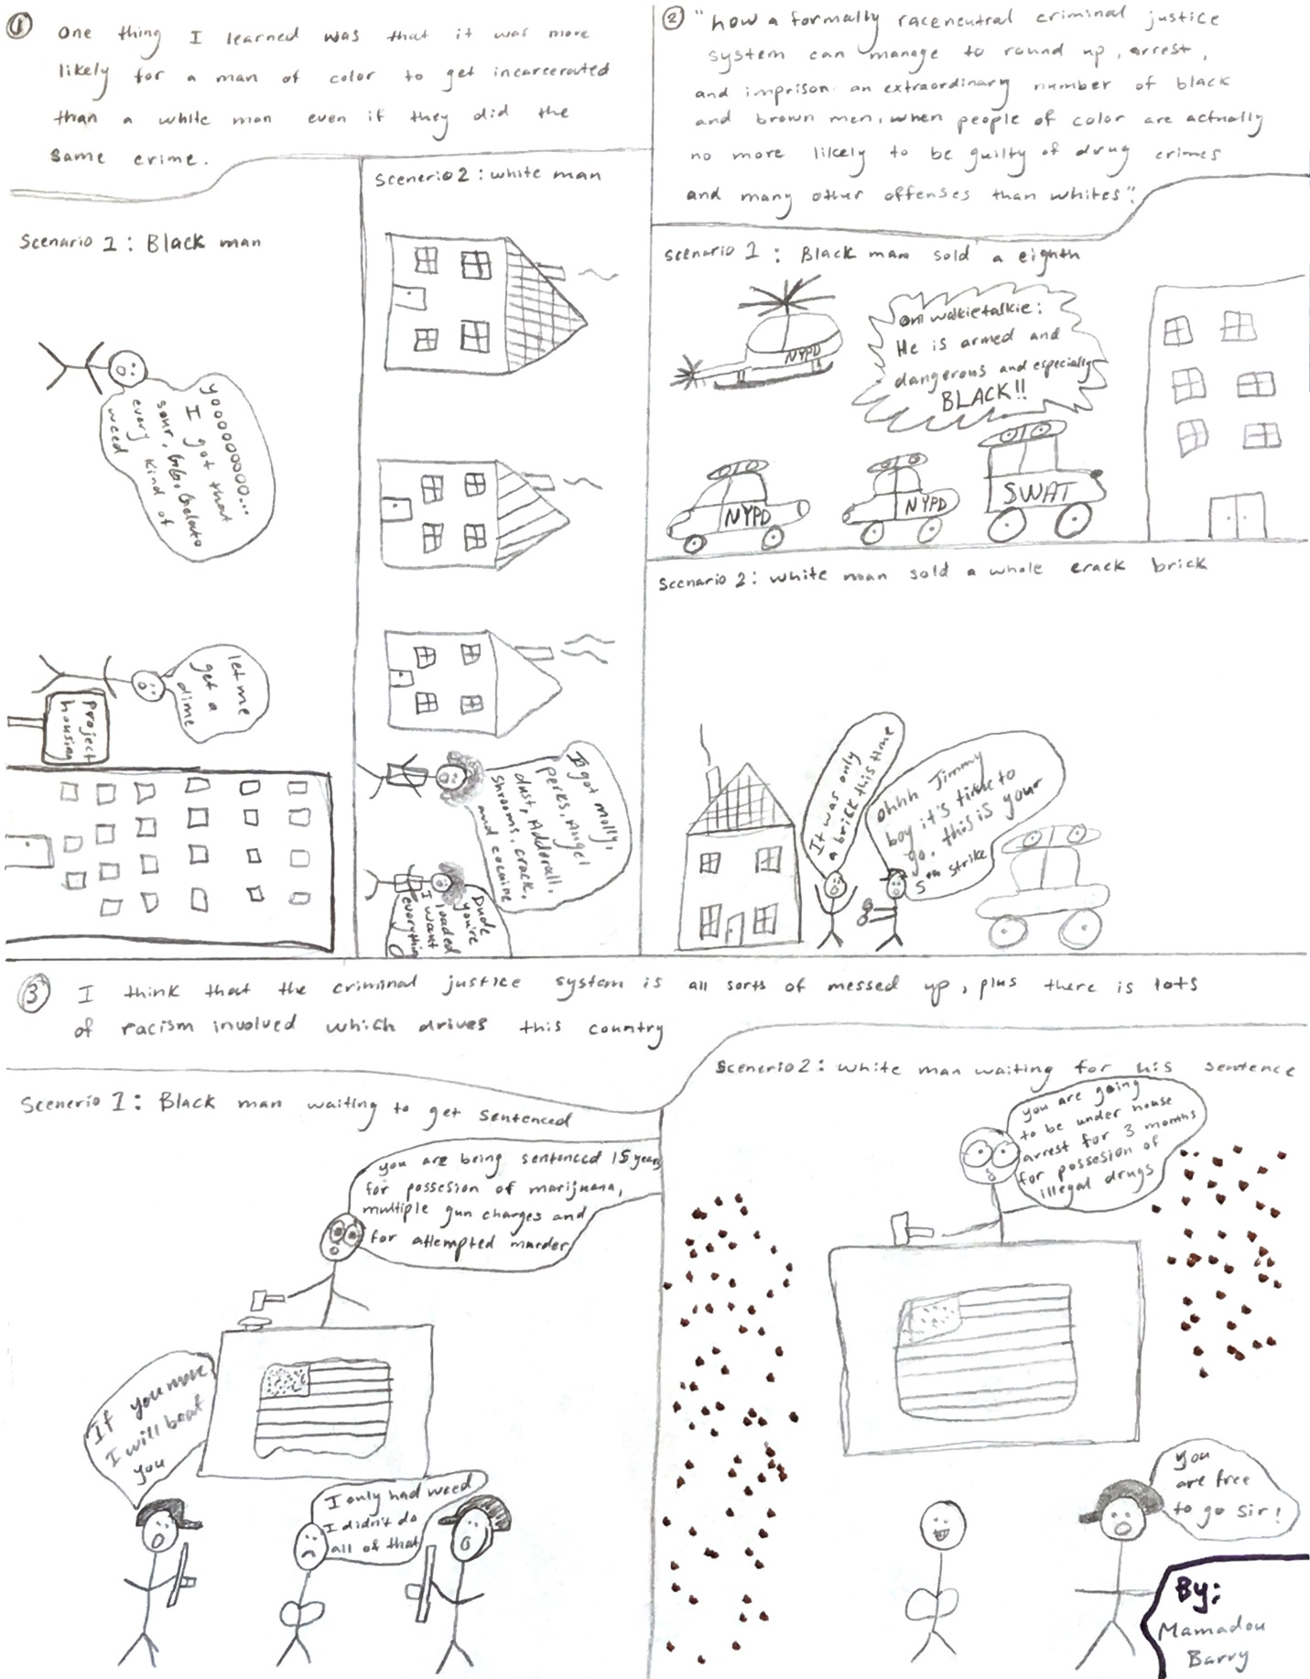

Tenth page—Mamadou Barry’s comic
(first of three frames): One thing I learned was that it was more likely for a man of color to get incarcerated than a white man even if they did the same crime. Illustration: scenario 1: Black man, shows two stick figures with picture of large apartment building labeled “project housing.” First figure has speech bubble saying, “Yooooooooo … I got that sour, G.G. Gelato, every kind of weed.” Second figure responds, “let me get a dime.” Scenario 2: white man, shows stereotypical single-family suburban housing with two stick figures, the first saying, “I got molly, percs, angel dust, Adderall, shrooms, crack, and cocaine.” Second figure responds, “Dude, you’re loaded. I want everything.”
(second of three frames): “How a formally race neutral criminal justice system can manage to round up, arrest, and imprison an extraordinary number of black and brown men, when people of color are actually no more likely to be guilty of drug crimes and many other offenses than whites.” Illustration: scenario 1: Black man sold an eighth, shows many NYPD vehicles, including helicopter and SWAT team headed toward apartment tower with walkie-talkie message, “He is armed and dangerous and especially black!!” Scenario 2: white man sold a whole crack brick, shows two stick figures in front of single family house with a single police car. Figure one has arms thrown up in distress, says, “It was only a brick this time.” Second figure holds out cuffs, saying, “Ohhhh Jimmy boy, it’s time to go. This is your 5th strike.”
(third of three frames): I think the justice system is all sorts of messed up, plus there is lots of racism involved which drives this country. Illustration: scenario 1: Black man waiting to get sentenced. Wide-eyed stick figure judge sitting at the bench appointed with a large American flag, says, “You are being sentenced to 15 years for possession of marijuana, multiple gun charges, and for attempted murder.” Armed stick figure police officers flank the accused, one of these threatening, “If you move I will beat you.” Stick figure accused in the center with frownie-face laments, “I only had weed. I didn’t do all of that.” Scenario 2: white man waiting for his sentence shows same stick figure judge at same bench saying, “You are going to be under house arrest for 3 months for possession of illegal drugs.” Court officer stick figure addresses smiling accused stick figure saying, “You are free to go, sir!”

Eleventh page—Madeline Lewis’ comic
(first of four frames): Working on Ishmael Beah’s A Long Way Gone, Madeline Lewis develops new insight into the exploitation of child soldiers, showing how violent anger results from triggering trauma.
(second of four frames): Anger. Illustration depicts dead stick figures lying amidst trees while one angry figure shoots a big gun outside the frame.
(third of four frames): Illustration shows shooter figure, now with neutral face, saying, “Every time I stopped shooting to change magazines and saw my two young lifeless friends, I angrily pointed my gun into the swamp and killed more people.”
(fourth of four frames): Illustration is smiling long-haired figure with thought bubbles noting, “I think the death of his friends caused Beah to kil other peoplel His friends are more like his brothers to him. Beah already lost his own family; so it made him feel like he just lost more family members.”
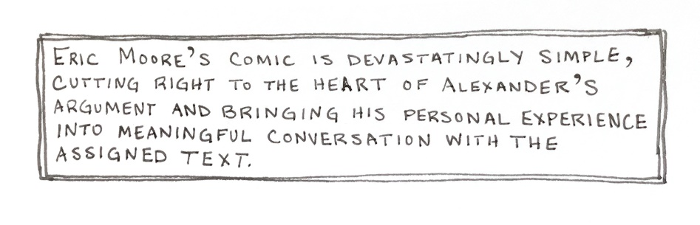

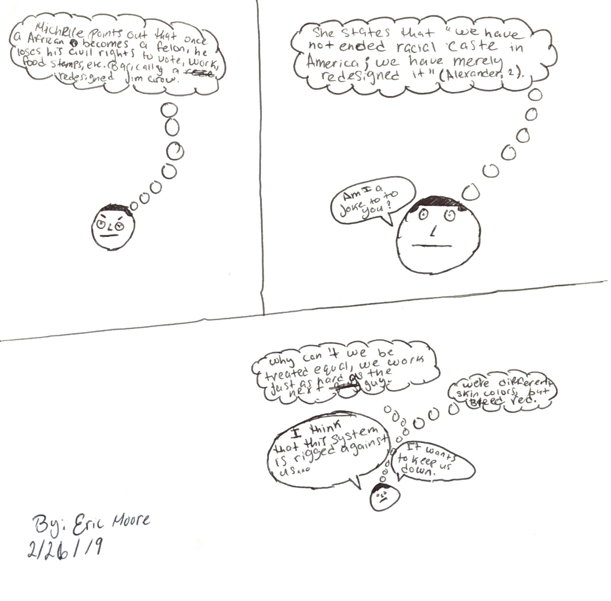

Twelfth page—Eric Moore’s comic
(first of four frames): Eric Moore’s comic is devastatingly simple, cutting right to the heart of Alexander’s argument and bringing his personal experience into meaningful conversation with the assigned text.
(second of four frames): Illustration is simple cartoon face with sardonic expression, thought bubble noting, “Michelle points out that once an African-American becomes a felon, he loses his civil rights to vote, work, food stamps, etc. Basically, a redesigned Jim Crow.”
(third of four frames): Illustration continues with simple cartoon face, bleak expression, thought bubble saying, “She states that ‘we have not ended racial caste in America; we have merely redesigned it’” (Alexander 2). Speech bubble asks, “Am I a joke to you?”
(fourth of four frames): Illustration continues with tiny cartoon face, with thought bubbles: “Why can’t we be treated equal? We work just as hard as the next guy.” And, “We’re different skin colors, but bleed red.” Two speech bubles comment, “I think that this system is rigged against us …” and “It wants to keep us down.”
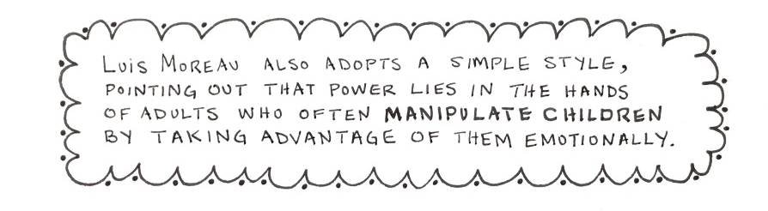

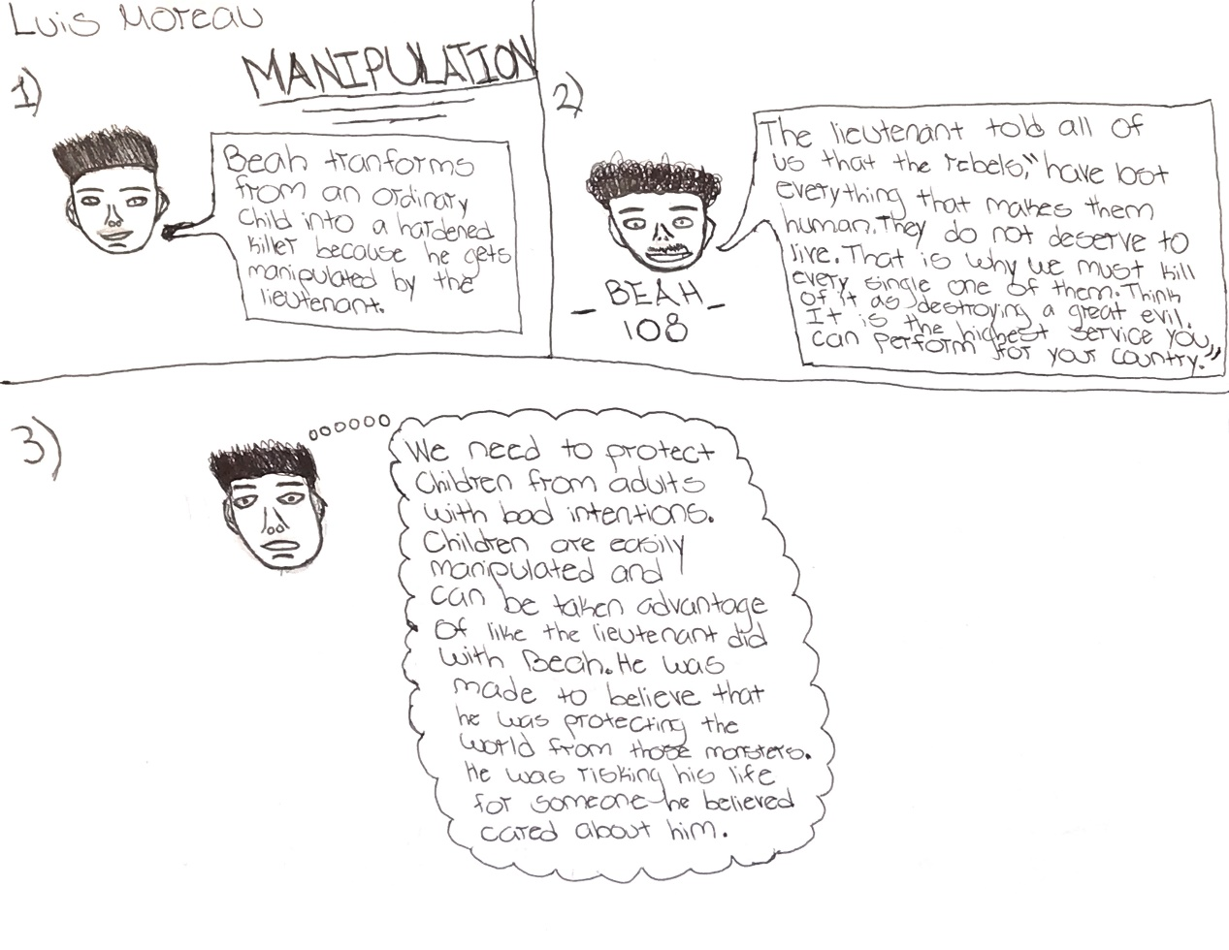

Thirteenth page—Luis Moreau’s comic
(first of four frames): Luis Moreau also adopts a simple style, pointing out that power lies in the hands of adults who often manipulate children by taking advantage of them emotionally.
(second of four frames): Illustration: Simple friendly face with spiky hair has speech bubble saying, “Beah transforms from an ordinary child into a hardened killer because he gets manipulated by the lieutenant.”
(third of four frames): Illustration: Simple face with curly hair has speech bubble saying, “The lieutenant told all of us that the rebels, ‘have lost everything that makes them human. They do not deserve to live. That is why we must kill every single one of them. Think of it as destroying a great evil. It is the highest service you can perform for your country.’”
(fourth of four frames): Illustration: Simple face with spiky hair shows thought bubble with the words, “We need to protect children from adults with bad intentions. Children are easily manipulated and can be taken advantage of like the lieutenant did with Beah. He was made to believe that he was protecting the world from these monsters. He was risking his life for someone he believed cared about him.”
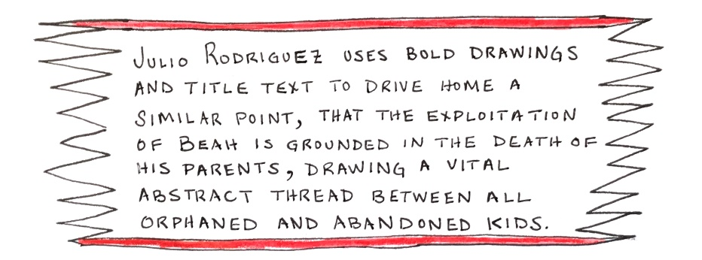
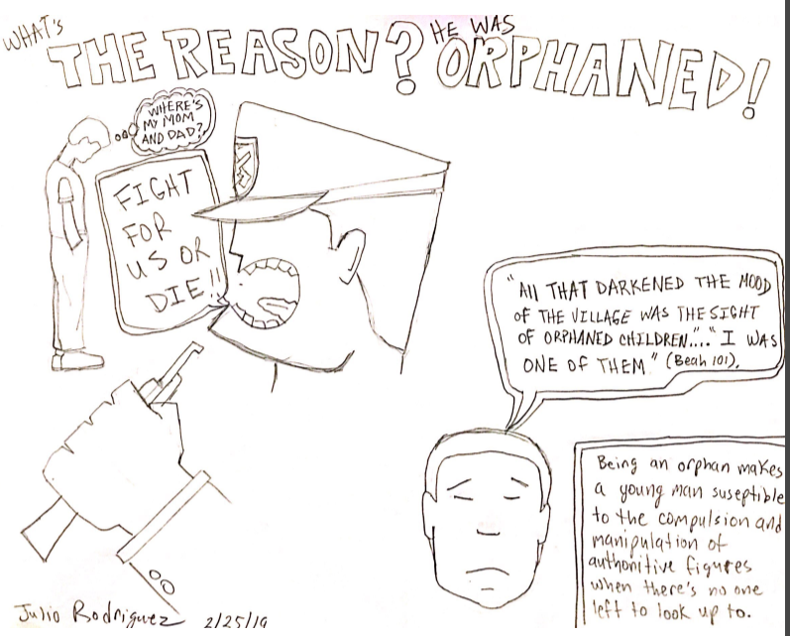
Fourteenth page—Julio Rodriguez’s comic
(first of four frames): Julio Rodriguez uses bold drawings and title text to drive home a similar point, that the exploitation of Beah is grounded in the death of his parents, drawing a vital abstract thread between all orphaned and abandoned kids.
(second of four frames): What’s the reason? He was orphaned!
(third of four frames): Illustration is fragile looking boy figure, hands in pockets, head hanging down with thought bubble showing him wondering, “Where’s my mom and dad?” while oversized head of square-jawed military authority, mouth wide open, assault weapon in his clenched fist, shouts, “Fight for us or die!”
(fourth of four frames): Illustration is mournful boy’s face saying, “All that darkened the mood of the village was the sight of orphaned children … I was one of them” (Beah 101). Caption reads: Being an orphan makes a young man susceptible to the compulsion and manipulation of authoritative figures when there’s no one left to look up to.
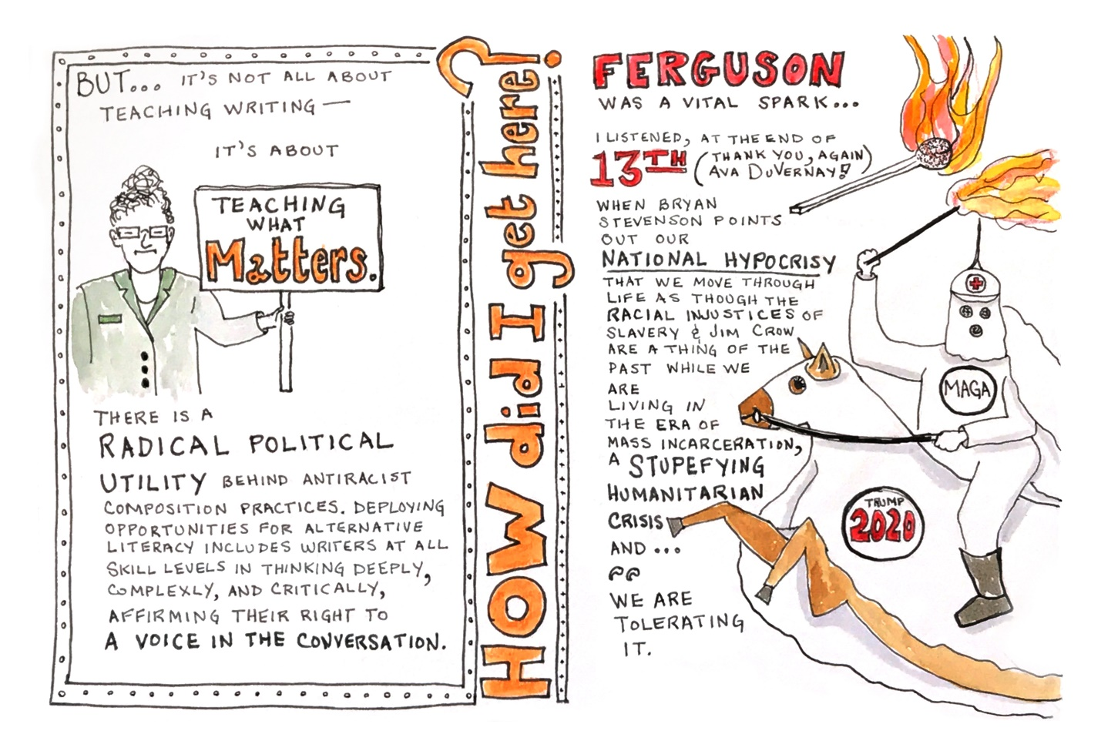
Fifteenth page
(first of three frames): BUT … it’s not all about teaching writing--it’s about teaching what matters. There is radical political utility behind antiracist composition practices. Deploying opportunities for alternative literacy includes writers at all skill levels in thinking deeply, complexly, and critically, affirming their right to a voice in the conversation. Illustration: Curly–haired, grim-faced, bespectacled professor figure holds sign reading, “Teaching What Matters.”
(second of three frames): How did I get here?
(third of three frames): Ferguson was a vital spark … I listened at the end of 13th (thank you, again, Ava DuVernay!) when Bryan Stevenson points out our national hypocrisy—that we move through life as though the racial injustices of slavery & Jim Crow are a thing of the past while we are living in the era of mass incarceration, a stupefying humanitarian crisis and … “we are tolerating it.” Illustrations show a lit match next to the Ferguson text and a chubby figure on horseback in Klan attire, the horse also draped in white, yielding a torch. The Klan figure is adorned with a MAGA symbol, the horse with a “Trump 2020” patch.

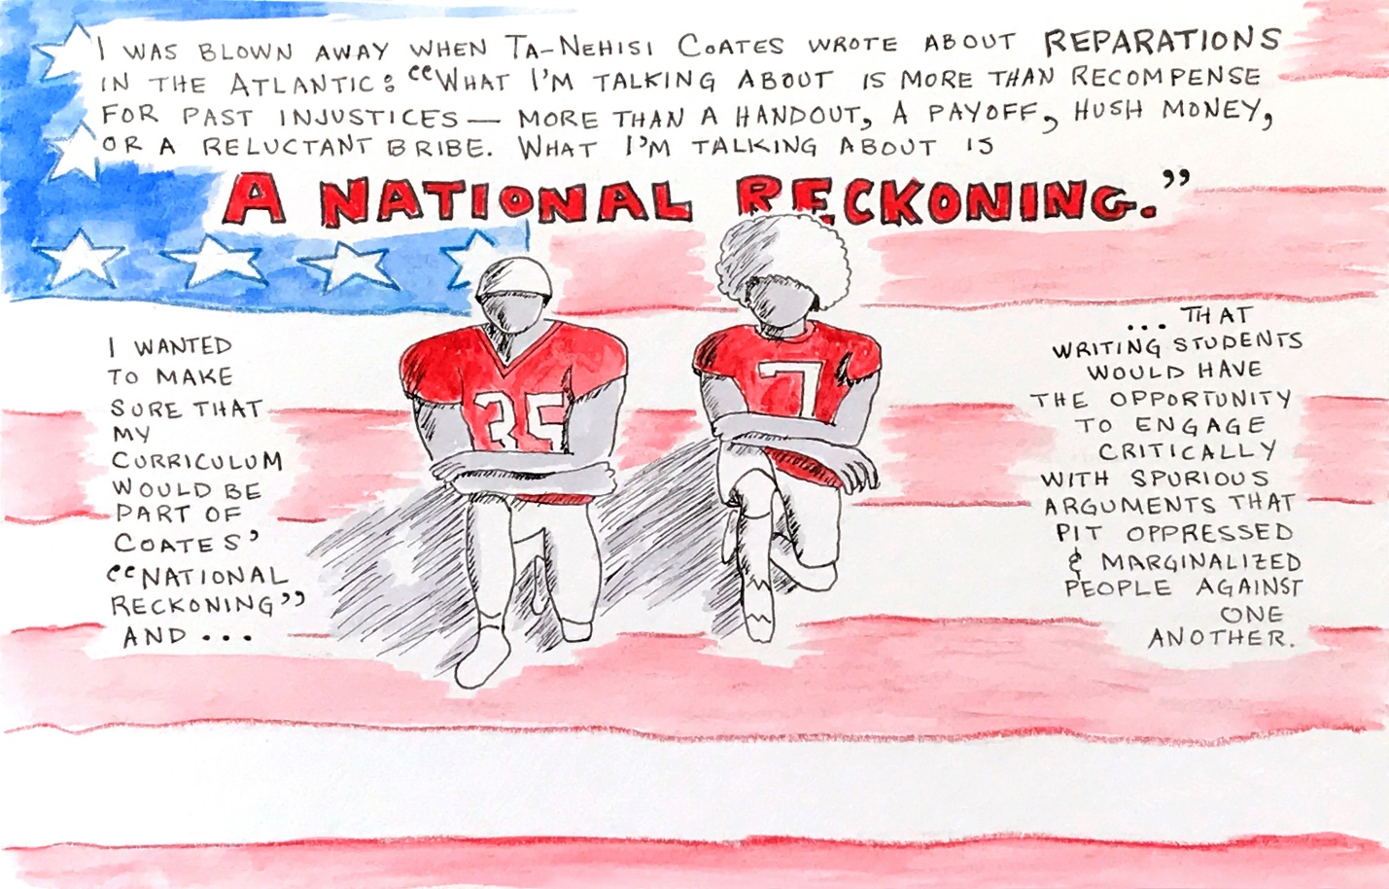
Sixteenth page
(one frame): I was blown away when Ta-Nehisi Coates wrote about Reparations in the Atlantic: “What I’m talking about is more than recompense for past injustices—more than a handout, a payoff, hush money, or a reluctant bribe. What I’m talking about is a national reckoning.” I wanted to make sure my curriculum would be part of Coates’ “national reckoning” and … that writing students would have the opportunity to engage critically with spurious arguments that pit oppressed and marginalized people against one another. Illustration: Kneeling silhouetted football players in the center of the page against an American flag backdrop.
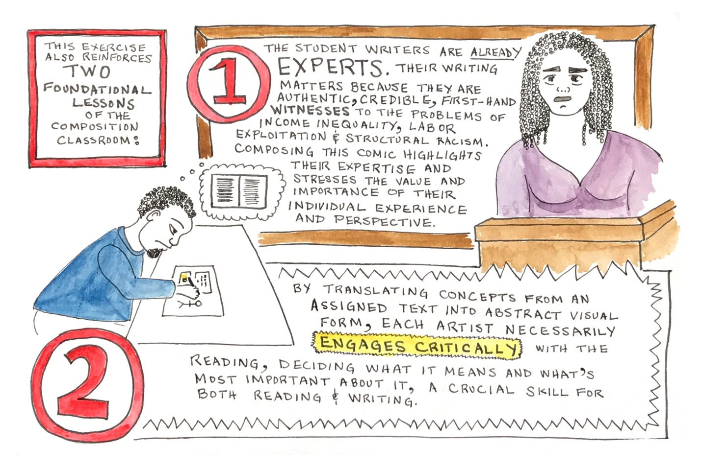Seventeenth page
(first of three frames): This exercise also reinforces two foundational lessons of the composition classroom.
(second of three frames): 1. The student writers are already experts. Their writing matters because they are authentic, credible first-hand witnesses to the problems of income inequality, labor exploitation & structural racism. Composing this comic highlights their expertise and stresses the value and importance of their individual experience and perspective. Illustration shows woman with long braids, testifying from a witness box.
(third of three frames): 2. By translating concepts from an assigned text into abstract visual form, each artist necessarily engages critically with the reading, deciding what it means and what’s most important about it, a crucial skill for both reading & writing. Illustration depicts bearded, curly-haired figure sitting at a table making a comic; a thought bubble coming from his head shows a picture of generic text on a printed page.
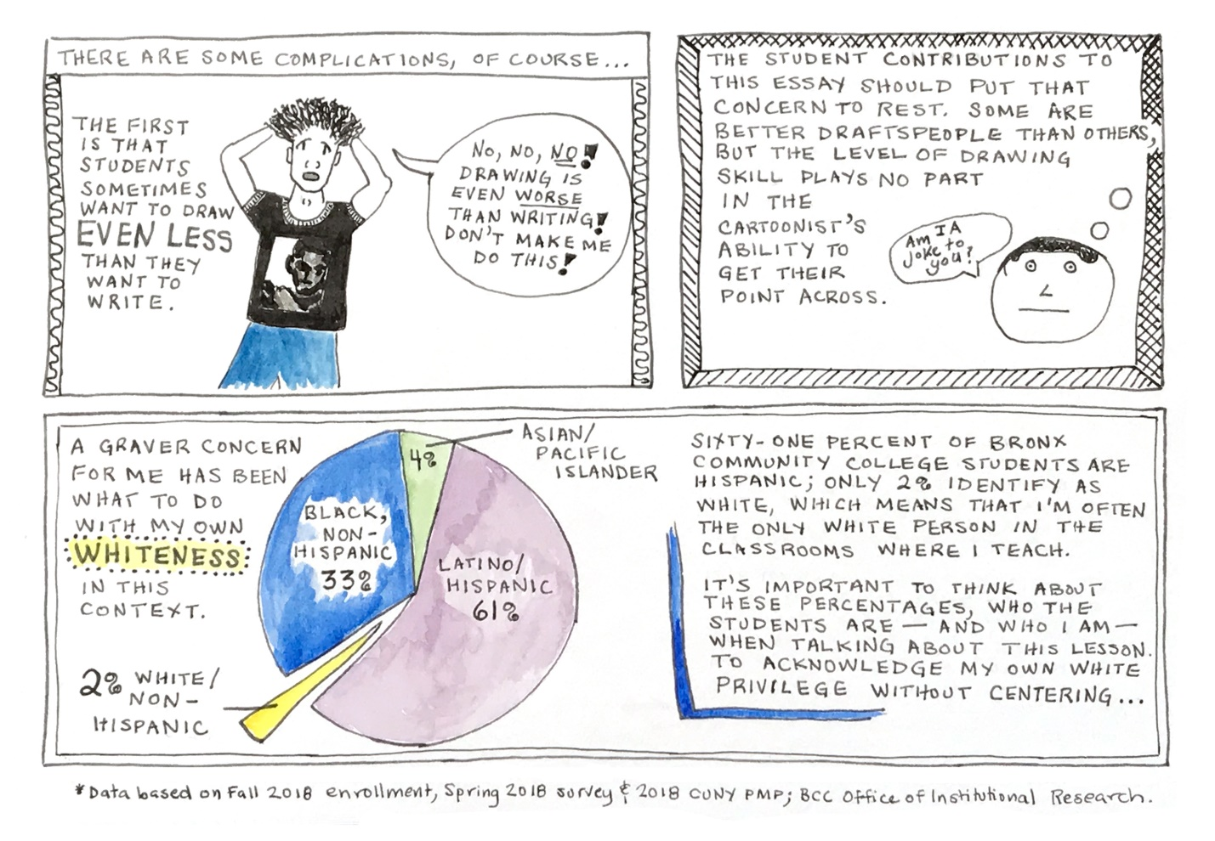
Eighteenth page
(first of three frames): There are some complications, of course … The first is that students sometimes want to draw even less than they want to write. Illustration shows student in black t-shirt featuring artistic portrait of a black man; student is pulling at his hair in distress, shouting, “No, no no! Drawing is even worse than writing! Don’t make me do this!”
(second of three frames): The student contributions to this essay should put that concern to rest. Some are better draftspeople than others, but the level of drawing skill plays no part in the cartoonist’s ability to get their point across. Illustration is a detail from Eric Moore’s comic, a bleak cartoon face with the words, “Am I a joke to you?”
(third of three frames): A graver concern for me has been what to do with my own whiteness in this context. Sixty-one percent of Bronx Community College Students are Hispanic; only 2% identify as white, which means that I’m often the only white person in the classrooms where I teach. It’s important to think about these percentages, who the students are--and who I am--when talking about this lesson. To acknowledge my own white privilege without centering … Illustration is a pie chart demonstrating the racial demographics at Bronx Community College: 33% Black, non-Hispanic; 4% Asian/Pacific Islander; 61% Latino/Hispanic; 2% white/non-Hispanic. *Data based on Fall 2018 enrollment, Spring 2018 survey & 2018 CUNY PMP; BCC Office of Institutional Research.

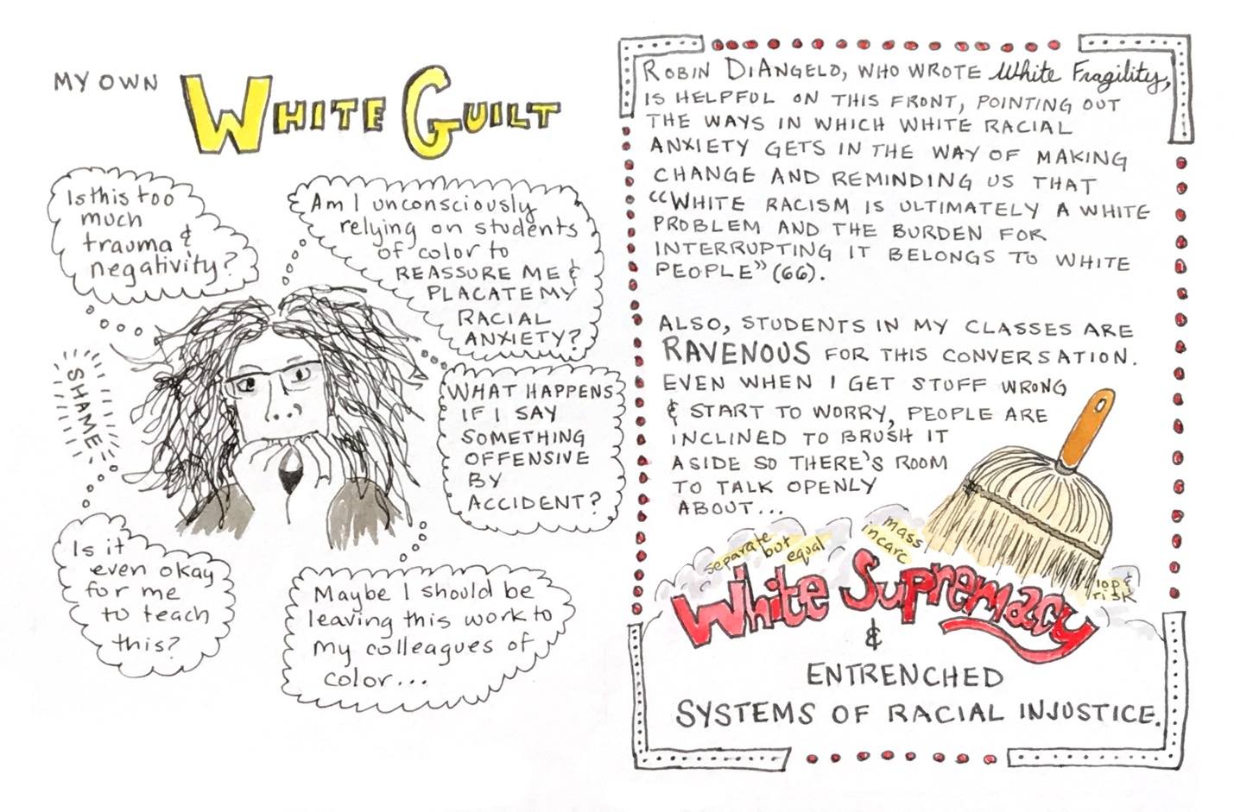
Nineteenth page
(first of two frames): My own White Guilt. Illustration is wild-haired bespectacled professor, wide-eyed, biting her nails surrounded by multiple thought bubbles, “Is this too much trauma and negativity?” “Am I unconsciously relying on students of color to reassure me & placate my racial anxiety?” “What happens if I say something offensive by accident?” “Is it even okay for me to teach this?” “Maybe I should be leaving this work to my colleagues of color …”
(second of two frames): Robin DiAngelo, who wrote White Fragility, is helpful on this front, pointing out the ways in which white racial anxiety gets in the way of making change, and reminding us that “White racism is ultimately a white problem and the burden for interrupting it belongs to white people” (66). Also, students in my classes are ravenous for this conversation. Even when I get stuff wrong & start to worry, people are inclined to brush it aside so there’s room to talk openly about … white supremacy & entrenched systems of racial injustice. Illustration shows broom sweeping away dust infused with phrases like “separate but equal,” “mass incarceration,” and “stop & frisk” to uncover large red letters spelling out “White Supremacy.”

Twentieth page
(first of four frames): What’s the Upshot?
(second of four frames): This graphic composition exercise disentangles students from the pressures of conforming conventional standards of (white) literacy while providing an avenue into antiracist reasoning & the discourse of public intellectuals of color.
(third of four frames, spanning the page): Illustration depicts full-bodied figure with straight brown hair and bangs, denim pants and midriff sleeveless top, their bottom half partially encircled with rope unfurling out of disembodied speech bubbles reading, “They can’t even write a complete sentence …” “That’s not a word.” “I before E except after C.” and “You’re reading at a fifth grade level!” Student’s upper body is leaning up and away, arms outstretched, escaping the “entanglement.” Student is saying, “I like having a chance to think about the reading without all the worry about getting things wrong!”
(fourth of four frames): Illustration is curly-headed professor figure with glasses, facing forward, arms crossed, saying, “What I love most about this exercise is the way it frees up student thinking, often resulting in compositions that show more insight & intellectual sophistication than their conventional essays. This richer understanding can later be tapped to add greater dimension to their regular expository writing.

END.

Thank you to Gino Miele for preparing these pages for publication, to Julia Havard, Chris Kennedy, Patrick Smyth, Josh Miele, and Sarah Chinn for helping me navigate the process of making this essay accessible for blind and visually impaired readers, and to Isabel Jacob for encouraging me to experiment in this medium. I am very grateful to you all.

Works Cited
13th. Directed by Ava DuVernay, Netflix, 2016.
Alexander, Michelle. The New Jim Crow: Mass Incarceration in the Age of Colorblindness. The New Press, 2012.
Beah, Ishmael. A Long Way Gone: Memoirs of a Boy Soldier. Sarah Crichton Books, 2007.
Coates, Ta-Nehisi. “The Case for Reparations.” The Atlantic, June 2014. www.theatlantic.com/magazine/archive/2014/06/the-case-for-reparations/361631/. Accessed 28 Mar 2019.
DiAngelo, Robin. “White Fragility.” International Journal of Critical Pedagogy, Vol. 3, No. 3, pp. 54-70.
Kraver, Jeraldine. “Reinventing the Composition Classroom, or How Making Comics Can Clarify the Composing Process.” SANE journal: Sequential Art Narrative in Education, Vol. 1, Iss. 3, 1 Jan 2013, pp. 30-46, digitalcommons.unl.edu/sane/vol1/iss3/4?utm_source=digitalcommons.unl.edu%2Fsane%2Fvol1%2Fiss3%2F4&utm_medium=PDF&utm_campaign=PDFCoverPages. Accessed 28 Mar 2019.
Scheg, Abigail G. “Give It a Taste: Serving Creative Writing in Small Doses.” Creative Composition: Inspiration and Techniques for Writing Instruction, edited by Danita Berg and Lori A. May, Multilingual Matters, 2015, pp. 24-29.

